**ONDC ONBOARDING CLI TOOL**

This tool is designed to help the network participants in **Onboarding** process. It is a java jar file which takes subscriber id as input from the user and generates the signing keys, encryption keys, request id and signature programmatically.

**HOW TO USE ONDC ONBOARDING CLI TOOL**

Steps --

1. Open command prompt in your system and go to the Directory where jar file is located.

In my demo documentation my directory is desktop

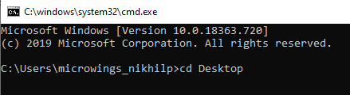

1. Type the command java -jar ondc-onboarding.jar and press enter.

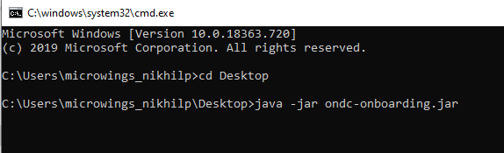

3. Press any key to continue

4. Enter your subscriber id here and press enter

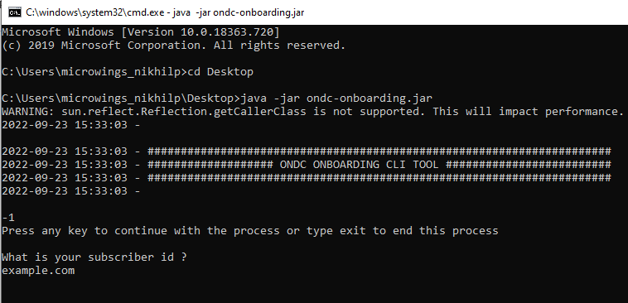

5. Tool will generate sign key pairs and ask you to overwrite the existing file if already exists.

6. Enter y to overwrite

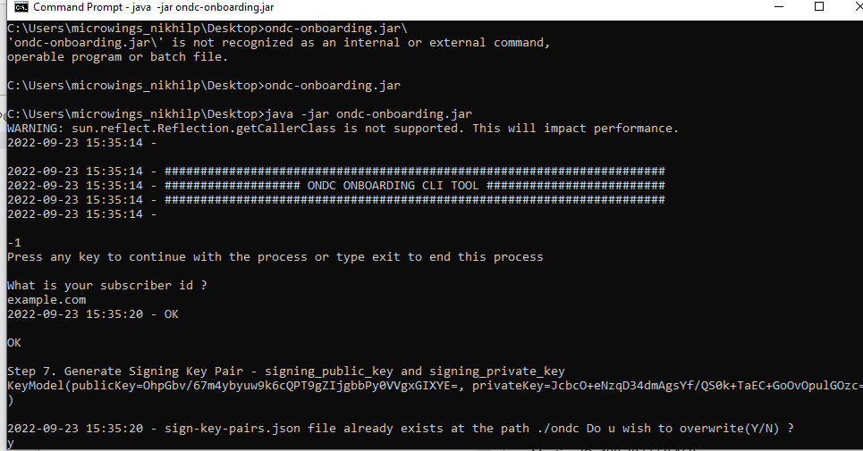

7. Next tool will generate Encryption key pairs and ask you to overwrite the existing file if already exists.

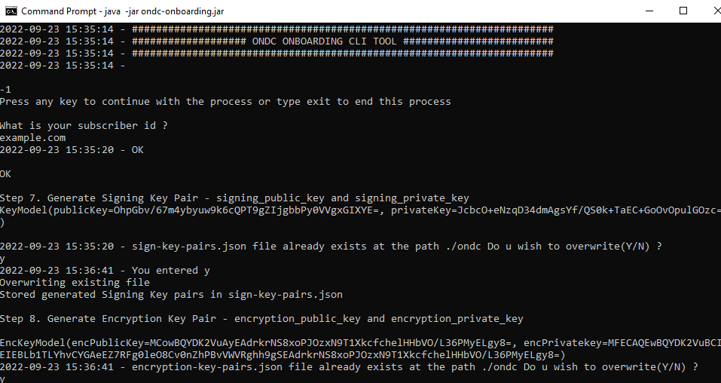

8. In next step tool will generate request id and ask you to overwrite the existing file if already exists.

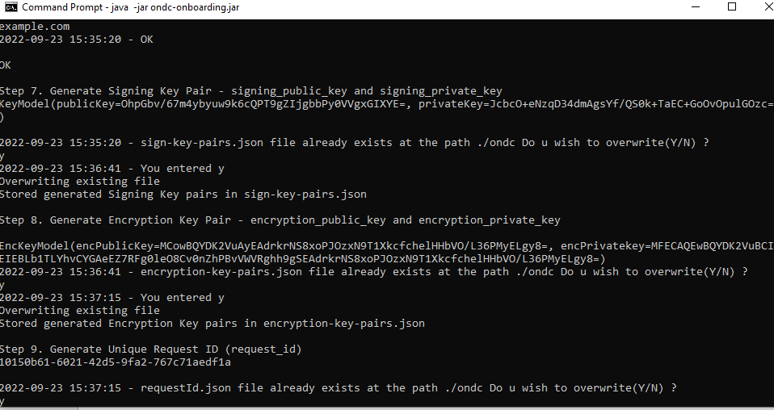

9. Request id will signed using your private key and placed automatically in the root folder of the ondc site created.

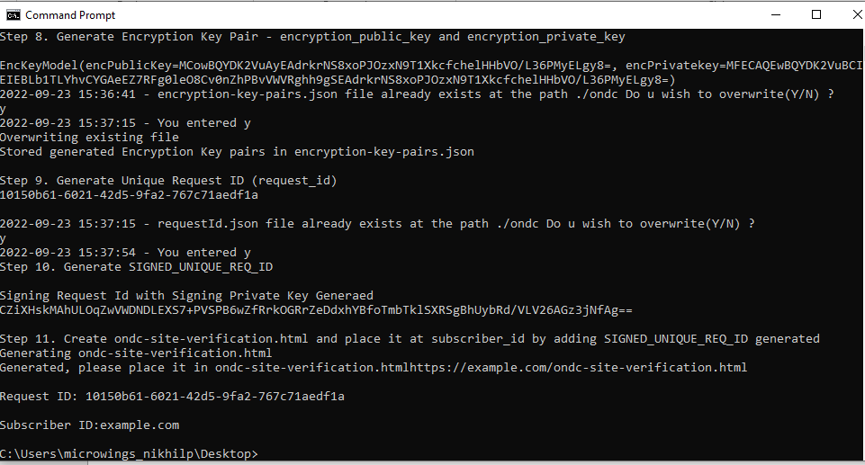

10. Go to the ondc folder generated on same directory where you place the jar all files stored here.

